安装说明(INSTALLATION)

硬件要求 (Hardware requirements)
处理器Processor | 1 GHz
内存 RAM | 512 MB
磁盘空间（最小值）Disk space (minimum)
32 位 32-bit | 850 MB
64 位 64-bit | 2 GB
支持的客户端操作系统(Supported client operating systems)
操作系统Operating system |  | Supported editions
Windows 8.1 |  | 32-bit and 64-bit
Windows 8 |  | 32-bit and 64-bit
Windows 7 SP1 |  | 32-bit and 64-bit
Windows Vista SP2 |  | 32-bit and 64-bit
系统下载 (Download)
- 从公司网页下载Framwork4.5 (Download Franwork4.5 from SNL Web)
http://lts.sinolines.net/webcontainer
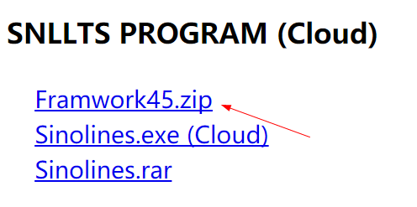
- 安装Framwork4.5 (Install Framwork4.5)

- 从公司网页下载Sinolines(Cloud) (Download Sinolines(Cloud) from SNL Web)
http://lts.sinolines.net/webcontainer

方法一：
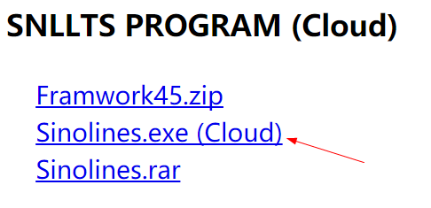
a) 下载的Sinolines.exe 文件保存到新建的单独目录 (Save the Sinolines.exe to separately folder)
b) 运行sinolines.exe，程序将自动升级至最新版本并运行。以后每次运行系统也会自动升级。(Run Sinolines.exe, program will download all files from web automatically. System will update automatically each running.)

方法二：
a) 将压缩文件sinolines.rar下载，(Download the compressed files.)
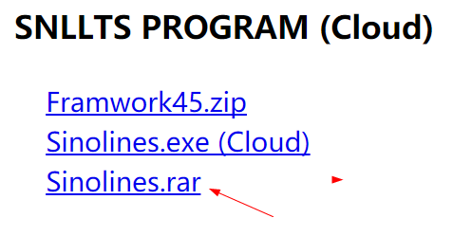
b) 解压缩文件，(Unzip the files.)
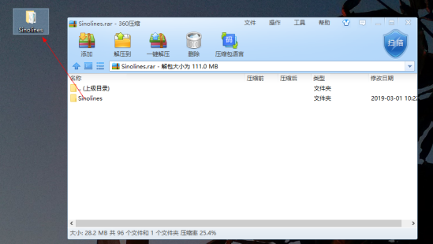

c) 运行sinolines.exe，程序将自动升级至最新版本并运行。以后每次运行系统也会自动升级。(Run Sinolines.exe, program will download all files from web automatically. System will update automatically each running.)
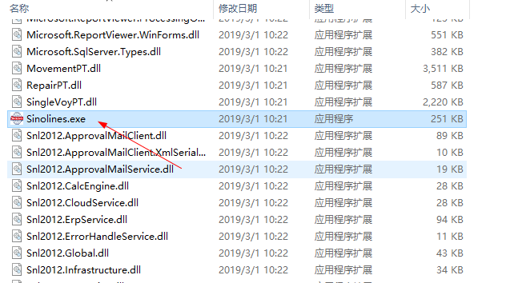

注：
1 新下载的Sinolines文件必须放在一个新建的目录中，不要放在旧版本目录中
(The downloaded new files must be saved into a new Local Directory. Don’t confuse with the old version catalogue.)

2 为保证系统正常更新，请把下列列表放到白名单(To download & update system smoothly, B/M sites should be listed in your server’s Whitelist.)
http://lts.sinolines.net
http://eprs.sinolines.net

